# Expected Value

Review Section 2.5 and 2.6 in Goldsman, D. & Goldsman, P. (2020). A First Course in Probability and Statistics. Lulu. [Download link](https://www.lulu.com/search?page=1&q=goldsman&pageSize=10&adult_audience_rating=00)

Other resources that are helpful when reviewing probability and statistics are:

<https://www.probabilitycourse.com/>

[Khan Academy](https://www.khanacademy.org/)

[YouTube](https://www.youtube.com/results?search_query=probability+and+statistics)

<https://stats.libretexts.org/Bookshelves>

## Why are Expected Value and Variance Important?

Having a solid understanding of expected values and variance of random variables is pivotal for simulation for several reasons:

* Central Tendency and Spread: At a fundamental level, the expected value (or mean) gives an average or central tendency of a random variable, while the variance provides a measure of its spread or variability. These two metrics are foundational for understanding the behavior and properties of random variables in a simulation.
* Performance Metrics: In many simulations, we're interested in predicting average outcomes or understanding the variability in outcomes. The expected value and variance directly give these insights. For instance, in financial simulations, the expected return on an investment and its variance (or volatility) are key metrics for investors.
* Comparative Analysis: When comparing different scenarios or strategies in a simulation, the expected values can be used to determine which scenario is, on average, more favorable. The variance can then indicate how much risk or variability is associated with each scenario.
* Monte Carlo Methods: Central to Monte Carlo simulations is the repeated sampling of random variables. The results of these repeated experiments can be used to estimate the expected value of some output. Additionally, the spread of these results gives an insight into its variance.
* Convergence and Stability: In iterative simulation methods, the convergence of results to a stable expected value can be an indicator of the simulation's stability. Variance provides information about the fluctuations or uncertainties in these results.
* Optimization under Uncertainty: When optimizing in stochastic environments, the objective might be to maximize the expected value of some quantity while possibly constraining its variance to manage risk.
* Law of Large Numbers: A foundational concept in probability and statistics is the Law of Large Numbers, which states that as the size of a sample increases, the sample mean (an average of sampled values) converges to the expected value of the random variable. This principle is heavily relied upon in simulations to ensure that the results are representative and reliable.
* Decision Making: In scenarios involving decision-making under uncertainty, expected utility or expected payoff becomes a crucial criterion. Variance or other measures derived from it, like the standard deviation, can be used to assess the risk associated with different decisions.
* Budgeting and Forecasting: In business or project management simulations, expected costs and revenues are vital for budgeting and forecasting. Variance provides insight into potential deviations from these expected values, aiding in contingency planning.
* Quality Control and Six Sigma: In manufacturing and quality control simulations, the expected value can indicate a process's central tendency, while the variance or standard deviation indicates its variability. Processes are often optimized to bring the expected value close to a target and reduce variance.
* Reliability Analysis: In fields like engineering or operations research, understanding the expected lifetime of a product and its variance can be crucial for planning maintenance, replacements, and warranties.

Expected values and variance serve as primary tools for summarizing, analyzing, and making decisions based on the outcomes of stochastic simulations. They offer a concise way to characterize the central tendencies and variabilities inherent in complex systems, making them indispensable for informed decision-making in uncertain environments.

## Bernoulli Expected Value Example

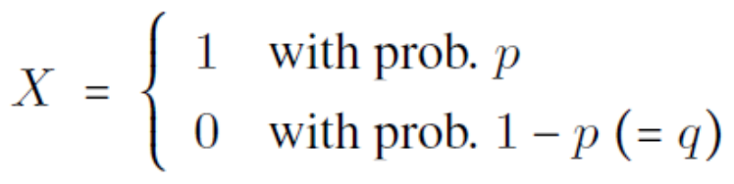

[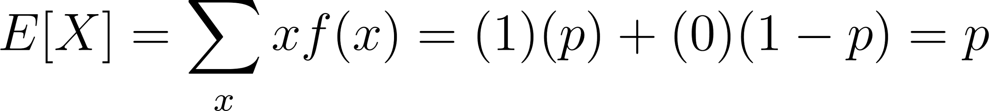](https://www.codecogs.com/eqnedit.php?latex=E%5BX%5D%3D%5Csum_x%20xf(x)%3D(1)(p)%2B(0)(1-p)%3Dp#0)

## Uniform Expected Value Example

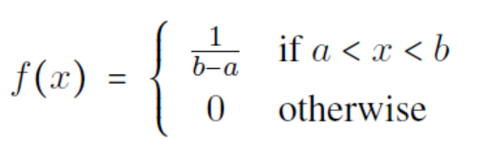

[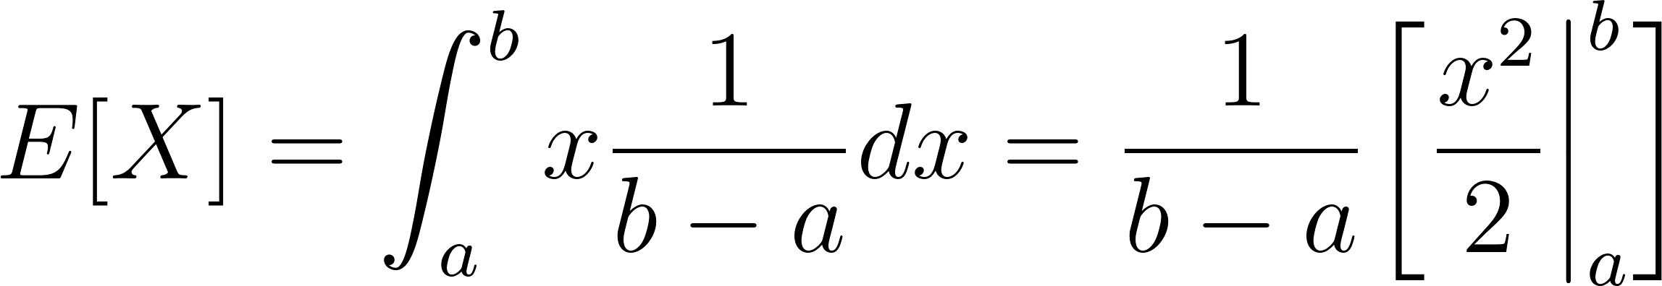](https://www.codecogs.com/eqnedit.php?latex=E%5BX%5D%3D%5Cint_a%5Eb%20x%20%5Cdfrac%7B1%7D%7Bb-a%7D%20dx%3D%5Cfrac%7B1%7D%7Bb-a%7D%5Cbigg%20%5B%5Cdfrac%7Bx%5E2%7D%7B2%7D%20%5Cbigg%20%5Crvert_a%5Eb%20%5Cbigg%5D#0)

[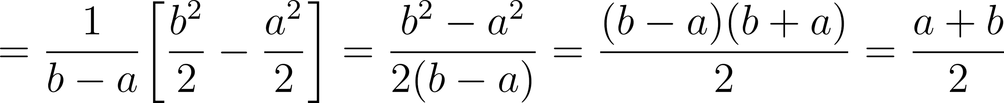](https://www.codecogs.com/eqnedit.php?latex=%3D%5Cdfrac%7B1%7D%7Bb-a%7D%5Cbigg%5B%5Cdfrac%7Bb%5E2%7D%7B2%7D-%5Cdfrac%7Ba%5E2%7D%7B2%7D%20%20%5Cbigg%5D%3D%5Cdfrac%7Bb%5E2-a%5E2%7D%7B2(b-a)%7D%3D%5Cdfrac%7B(b-a)(b%2Ba)%7D%7B2%7D%3D%5Cdfrac%7Ba%2Bb%7D%7B2%7D#0)

## Exponential Expected Value Example

There are three slightly different ways to approach this integration. Use whichever method makes the most sense to you.

### Integration By Parts

[The integral is an](https://latex-staging.easygenerator.com/eqneditor/editor.php?latex=g'(x)%3D%5Clambda%20e%5E%7B-lambda%20x%7D#0) [improper integral](https://en.wikipedia.org/wiki/Improper_integral)[, so we rewrite it using limits and include a change of variable for clarity.](https://latex-staging.easygenerator.com/eqneditor/editor.php?latex=g'(x)%3D%5Clambda%20e%5E%7B-lambda%20x%7D#0)

[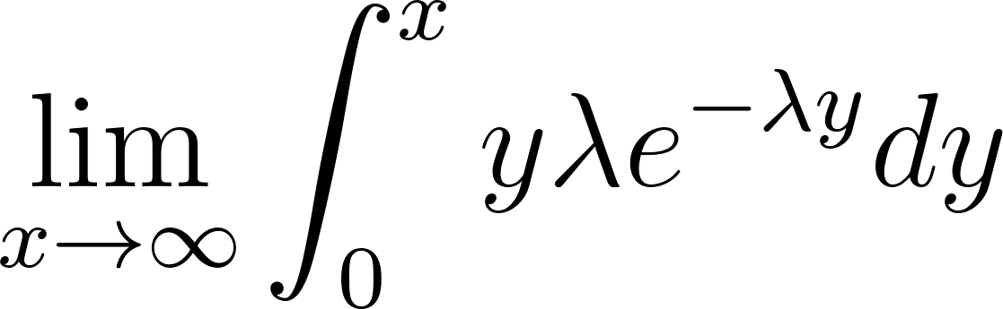](https://www.codecogs.com/eqnedit.php?latex=%5Clim_%7Bx%20%5Crightarrow%20%5Cinfty%7D%20%5Cint_0%5Ex%20y%20%5Clambda%20e%5E%7B-%5Clambda%20y%7D%20dy#0)

Let [](https://www.codecogs.com/eqnedit.php?latex=f(y)%3Dy%2C%20f'(y)%3D1%2C%20g(y)%3D-e%5E%7B-%5Clambda%20y%7D%2C#0) and [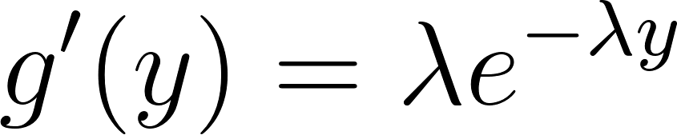](https://www.codecogs.com/eqnedit.php?latex=g'(y)%3D%5Clambda%20e%5E%7B-%5Clambda%20y%7D#0)

Rewrite using integration by parts:

[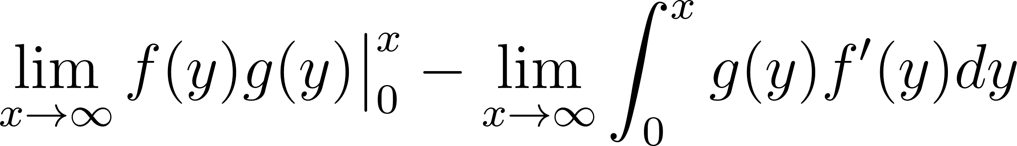](https://www.codecogs.com/eqnedit.php?latex=%5Clim_%7Bx%20%5Crightarrow%20%5Cinfty%7D%20f(y)g(y)%20%5Cbig%20%5Crvert_0%5Ex%20-%20%5Clim_%7Bx%20%5Crightarrow%20%5Cinfty%7D%20%5Cint_0%5Ex%20g(y)f'(y)%20dy#0)

[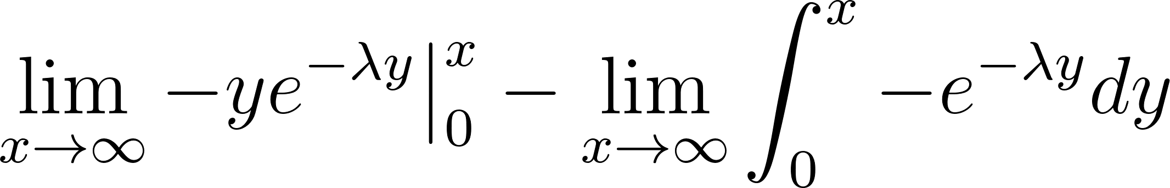](https://www.codecogs.com/eqnedit.php?latex=%5Clim_%7Bx%20%5Crightarrow%20%5Cinfty%7D%20-ye%5E%7B-%5Clambda%20y%7D%20%20%5Cbig%20%5Crvert_0%5Ex%20-%20%5Clim_%7Bx%20%5Crightarrow%20%5Cinfty%7D%20%5Cint_0%5Ex%20-e%5E%7B-%5Clambda%20y%7D%20dy#0)

[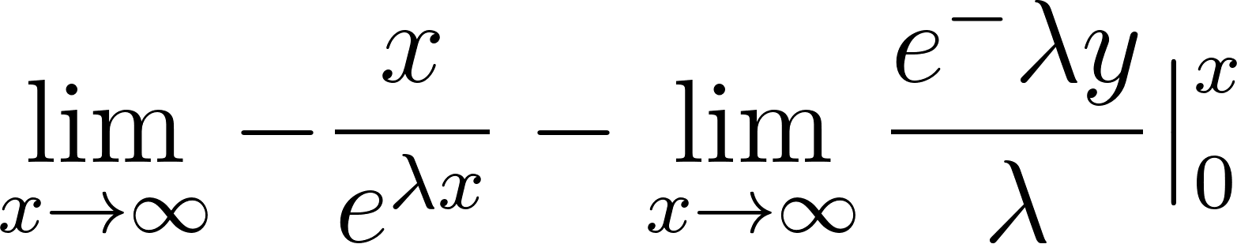](https://www.codecogs.com/eqnedit.php?latex=%5Clim_%7Bx%20%5Crightarrow%20%5Cinfty%7D%20-%5Cdfrac%7Bx%7D%7Be%5E%7B%5Clambda%20x%7D%7D-%20%5Clim_%7Bx%20%5Crightarrow%20%5Cinfty%7D%20%5Cdfrac%7Be%5E-%7B%5Clambda%20y%7D%7D%7B%5Clambda%7D%20%5Cbig%20%5Crvert_0%5Ex#0)

The first term results in [](https://www.codecogs.com/eqnedit.php?latex=%5Cinfty%20%2F%20%5Cinfty#0) which is an [indeterminate form](https://en.wikipedia.org/wiki/Indeterminate_form), so [L’Hospital’s rule](https://en.wikipedia.org/wiki/L%27H%C3%B4pital%27s_rule) is needed.

[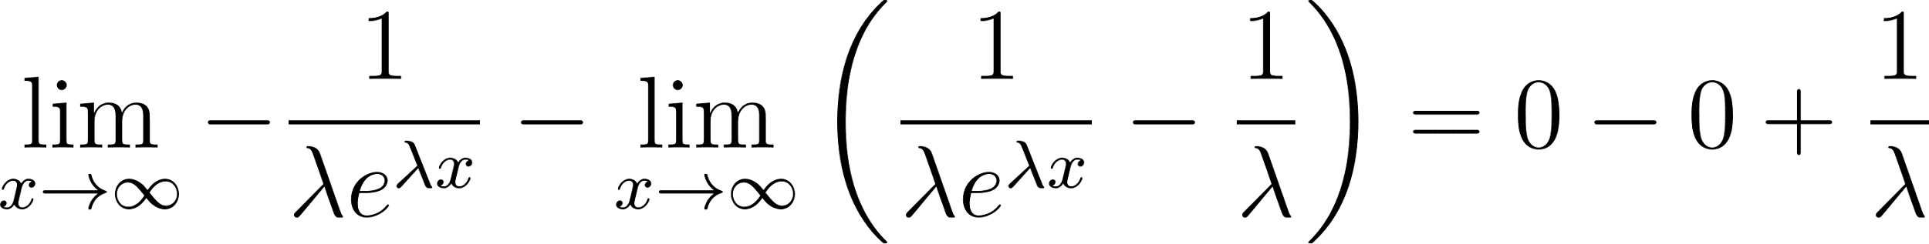](https://www.codecogs.com/eqnedit.php?latex=%5Clim_%7Bx%20%5Crightarrow%20%5Cinfty%7D%20-%5Cdfrac%7B1%7D%7B%5Clambda%20e%5E%7B%5Clambda%20x%7D%7D-%5Clim_%7Bx%20%5Crightarrow%20%5Cinfty%7D%20%5Cbigg(%20%5Cdfrac%7B1%7D%7B%5Clambda%20e%5E%7B%5Clambda%20x%7D%7D%20-%20%5Cdfrac%7B1%7D%7B%5Clambda%7D%20%5Cbigg)%3D0-0%2B%5Cdfrac%7B1%7D%7B%5Clambda%7D#0)

### Transforming Using the Gamma Distribution

The [probability density function (pdf)](https://en.wikipedia.org/wiki/Probability_density_function) of the [gamma distribution](https://en.wikipedia.org/wiki/Gamma_distribution) is

[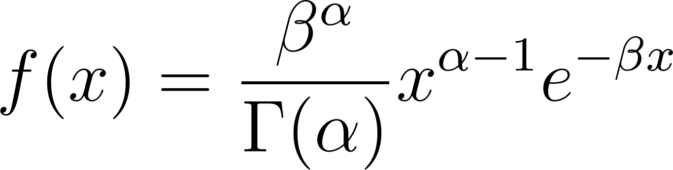](https://www.codecogs.com/eqnedit.php?latex=f(x)%3D%5Cdfrac%7B%5Cbeta%5E%7B%5Calpha%7D%7D%7B%5CGamma%20(%5Calpha)%7Dx%5E%7B%5Calpha%20-%201%7De%5E%7B-%5Cbeta%20x%7D#0)

Note that the function we are trying to integrate, [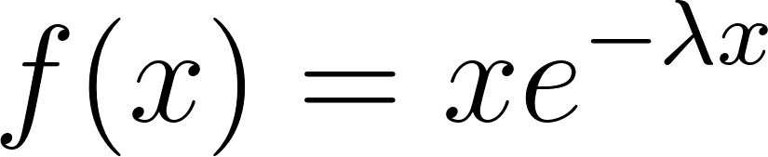](https://www.codecogs.com/eqnedit.php?latex=f(x)%3Dx%20e%5E%7B-%5Clambda%20x%7D#0) looks similar to this. The strategy here is to rewrite the integral in such a way that part of it represents the pdf of the gamma distribution. Integrating over the entire support of a distribution yields 1, so that will make that piece of the integration much easier. Where [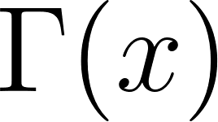](https://www.codecogs.com/eqnedit.php?latex=%5CGamma(x)#0) is the [gamma function](https://en.wikipedia.org/wiki/Gamma_function) and is defined as [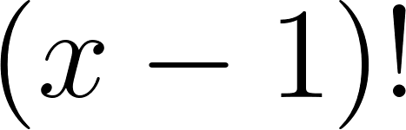](https://www.codecogs.com/eqnedit.php?latex=(x-1)!#0) for this application.

If we let [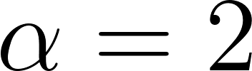](https://www.codecogs.com/eqnedit.php?latex=%5Calpha%20%3D%202#0) and [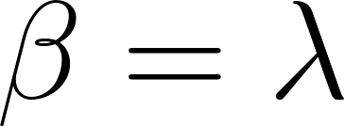](https://www.codecogs.com/eqnedit.php?latex=%5Cbeta%20%3D%20%5Clambda#0), we can write the pdf as follows:

[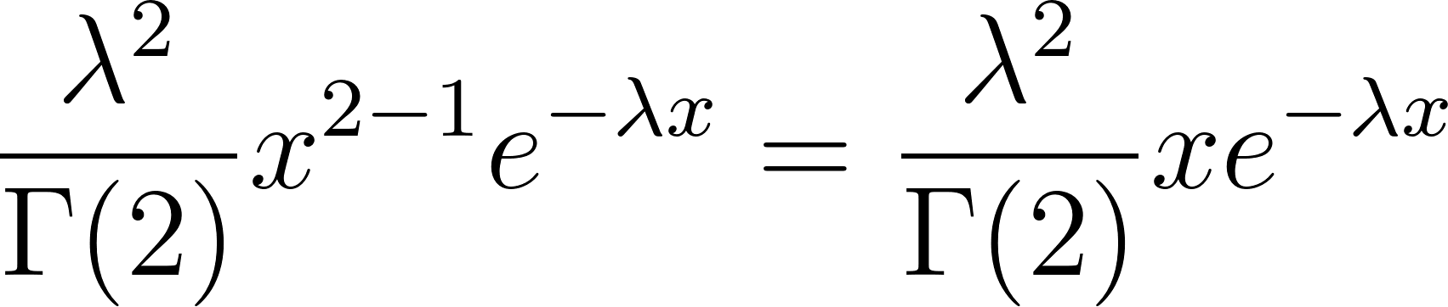](https://www.codecogs.com/eqnedit.php?latex=%5Cdfrac%7B%5Clambda%5E2%7D%7B%5CGamma%20(2)%7D%20x%5E%7B2-1%7De%5E%7B-%5Clambda%20x%7D%3D%5Cdfrac%7B%5Clambda%5E2%7D%7B%5CGamma%20(2)%7D%20xe%5E%7B-%5Clambda%20x%7D#0)

Notice the [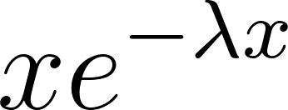](https://www.codecogs.com/eqnedit.php?latex=xe%5E%7B-%5Clambda%20x%7D#0) in the expression above.

We can now integrate this as follows:

[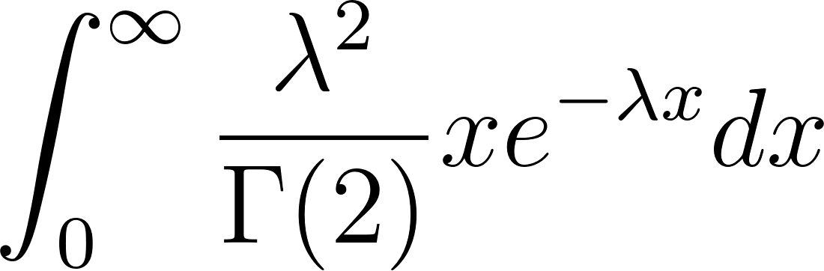](https://www.codecogs.com/eqnedit.php?latex=%5Cint_0%5E%7B%5Cinfty%7D%5Cdfrac%7B%5Clambda%5E2%7D%7B%5CGamma%20(2)%7D%20xe%5E%7B-%5Clambda%20x%7D%20dx#0)

We can’t just arbitrarily add the additional constant in front and forget about the [](https://www.codecogs.com/eqnedit.php?latex=%5Clambda#0) that was a constant in the original function, but we can multiply the entire integral by the reciprocal of that constant and that will actually be equivalent to the original integral that we want to integrate. We can also pull out the [](https://www.codecogs.com/eqnedit.php?latex=%5Clambda#0) that was in the expression [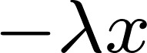](https://latex-staging.easygenerator.com/eqneditor/editor.php?latex=%5Cxe%5E%7B-%5Clambda%20x%7D#0) and place it in front of the integral as well.

[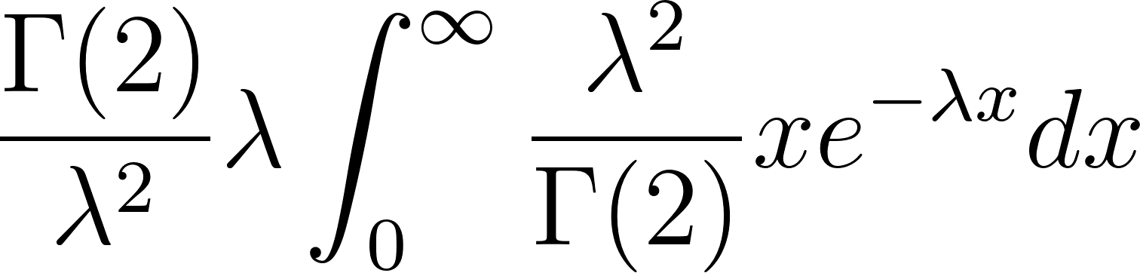](https://www.codecogs.com/eqnedit.php?latex=%5Cdfrac%7B%5CGamma(2)%7D%7B%5Clambda%5E2%7D%20%5Clambda%5Cint_0%5E%7B%5Cinfty%7D%5Cdfrac%7B%5Clambda%5E2%7D%7B%5CGamma%20(2)%7D%20xe%5E%7B-%5Clambda%20x%7D%20dx#0)

The integral is equivalent to 1 as explained above since it is the pdf of the gamma distribution.

We are left with [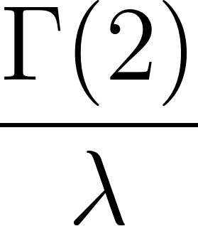](https://www.codecogs.com/eqnedit.php?latex=%5Cdfrac%7B%5CGamma(2)%7D%7B%5Clambda%7D#0)

[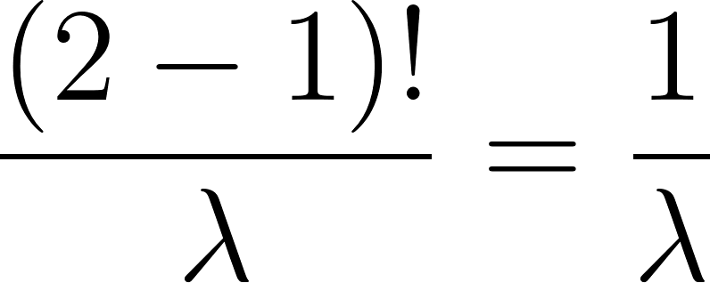](https://www.codecogs.com/eqnedit.php?latex=%5Cdfrac%7B(2-1)!%7D%7B%5Clambda%7D%3D%5Cdfrac%7B1%7D%7B%5Clambda%7D#0) which is the same result we got when integrating by parts.

### Transforming Using the Gamma Function

Another approach to integrating this is using the Gamma function using the integral definition of it:

[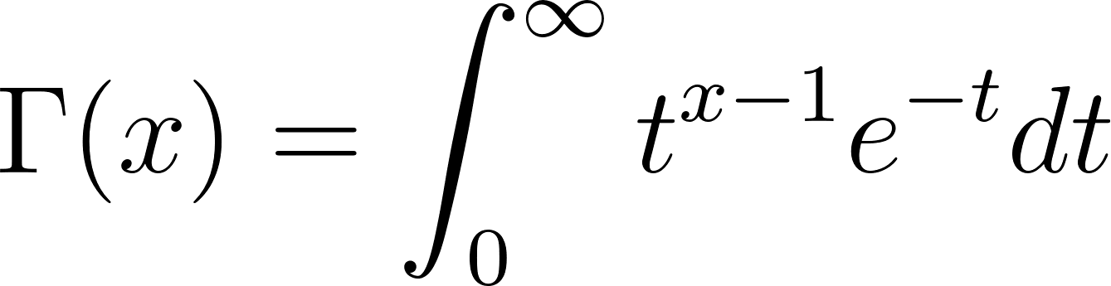](https://www.codecogs.com/eqnedit.php?latex=%5CGamma(x)%3D%5Cint_0%5E%7B%5Cinfty%7Dt%5E%7Bx-1%7De%5E%7B-t%7Ddt#0)

Using substitution and letting [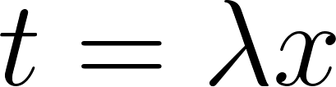](https://www.codecogs.com/eqnedit.php?latex=t%3D%5Clambda%20x#0) so [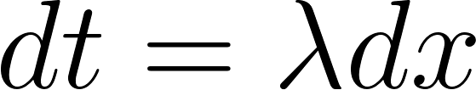](https://www.codecogs.com/eqnedit.php?latex=dt%3D%5Clambda%20dx#0) then [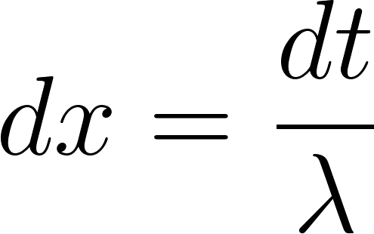](https://www.codecogs.com/eqnedit.php?latex=dx%3D%5Cdfrac%7Bdt%7D%7B%5Clambda#0)

The original integral can be rewritten as follows:

[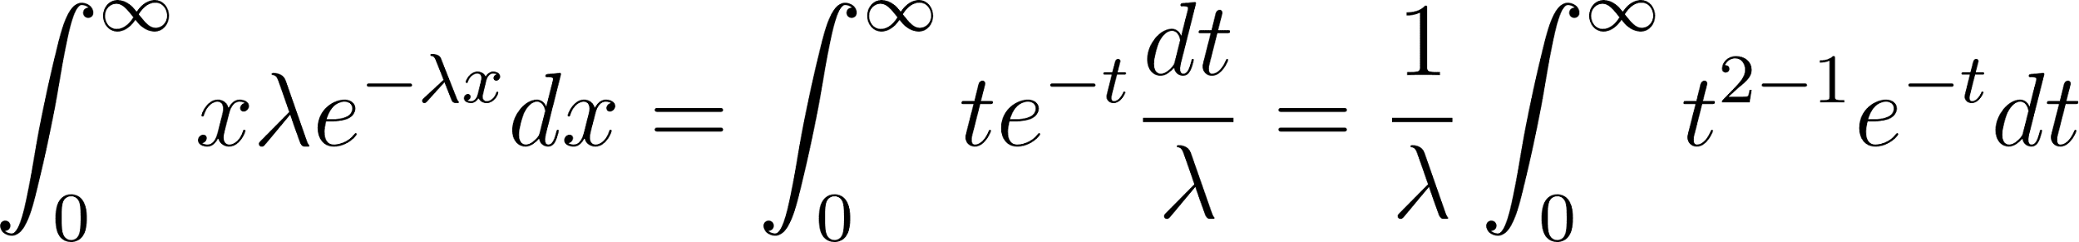](https://www.codecogs.com/eqnedit.php?latex=%5Cint_0%5E%7B%5Cinfty%7D%20x%20%5Clambda%20e%5E%7B-%5Clambda%20x%7D%20dx%3D%5Cint_0%5E%5Cinfty%20t%20e%5E%7B-t%7D%20%5Cdfrac%7Bdt%7D%7B%5Clambda%7D%3D%5Cdfrac%7B1%7D%7B%5Clambda%7D%5Cint_0%5E%7B%5Cinfty%7D%20t%5E%7B2-1%7D%20e%5E%7B-t%7D%20dt#0)

The integral is equivalent to [](https://www.codecogs.com/eqnedit.php?latex=%5CGamma(2)%3D(2-1)!%3D1!%3D1#0) so we are left with [](https://www.codecogs.com/eqnedit.php?latex=%5Cdfrac%7B1%7D%7B%5Clambda%7D#0) which is the same result using the other two methods.

# The Law of the Unconscious Statistician (LOTUS)

The [Law of the Unconscious Statistician (LOTUS)](https://en.wikipedia.org/wiki/Law_of_the_unconscious_statistician) is a theorem in probability theory that relates to the computation of the expected value of a function of a random variable. It provides a convenient way to compute the expected value of a function without needing to find the distribution of that function. The theorem is called "unconscious" because it's often used without people realizing they're using it.

Here are some examples of why one might find LOTUS useful.

1. Insurance: Consider an insurance company that offers coverage for a certain type of natural disaster, like floods. Let [](https://www.codecogs.com/eqnedit.php?latex=X#0) represent the amount of damage a policyholder may suffer due to a flood, with a known probability mass function [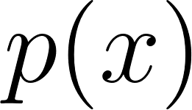](https://www.codecogs.com/eqnedit.php?latex=p(x)#0). The insurance company might offer a deductible of D dollars, meaning they will only pay for damages exceeding D dollars. The payout function [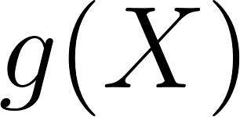](https://www.codecogs.com/eqnedit.php?latex=g(X)#0) would be [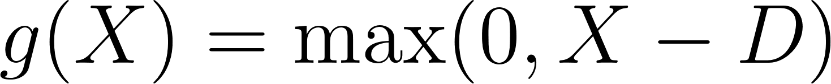](https://www.codecogs.com/eqnedit.php?latex=g(X)%20%3D%20%5Cmax(0%2C%20X%20-%20D)#0). The insurance company would use LOTUS to find the expected payout to determine the appropriate premium for this policy.

2. Finance: Suppose an investor wants to invest in a stock that has a known probability distribution of returns. Let [](https://www.codecogs.com/eqnedit.php?latex=X#0) be the random variable representing the stock's return, with a known probability density function [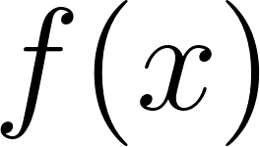](https://www.codecogs.com/eqnedit.php?latex=f(x)#0). The investor wants to compare the expected return of investing in the stock for one year versus keeping the money in a risk-free savings account with an interest rate of [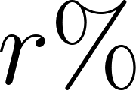](https://www.codecogs.com/eqnedit.php?latex=r%5C%25#0). The investor's function [](https://www.codecogs.com/eqnedit.php?latex=g(X)#0) would be [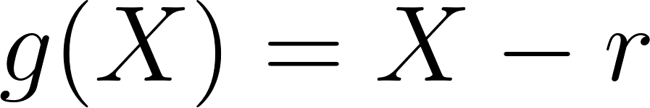](https://www.codecogs.com/eqnedit.php?latex=g(X)%20%3D%20X%20-%20r#0). The investor can use LOTUS to calculate the expected excess return and make an informed decision about the investment.

3. Quality control: A factory produces light bulbs, and the lifetime of each bulb (in hours) can be modeled as a random variable [](https://www.codecogs.com/eqnedit.php?latex=X#0) with a known probability density function [](https://www.codecogs.com/eqnedit.php?latex=f(x)#0). The factory wants to estimate the expected proportion of bulbs that will last less than a specified number of hours, say T hours. The factory can define a function [](https://www.codecogs.com/eqnedit.php?latex=g(X)#0) as [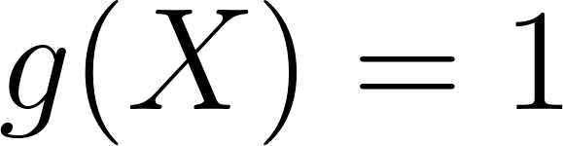](https://www.codecogs.com/eqnedit.php?latex=g(X)%20%3D%201#0) if [](https://www.codecogs.com/eqnedit.php?latex=X%20%3C%20T#0) and [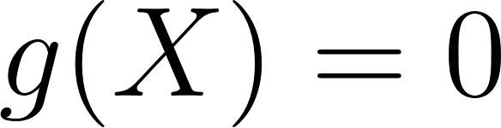](https://www.codecogs.com/eqnedit.php?latex=g(X)%20%3D%200#0) otherwise. Using LOTUS, the factory can estimate the expected proportion of bulbs that will fail before T hours..

4. Public health: Suppose a vaccination campaign is being implemented to control the spread of a disease. Let [](https://www.codecogs.com/eqnedit.php?latex=X#0) represent the number of people who receive the vaccine, with a known probability mass function [](https://www.codecogs.com/eqnedit.php?latex=p(x)#0). The vaccine is known to reduce the probability of infection by a factor of [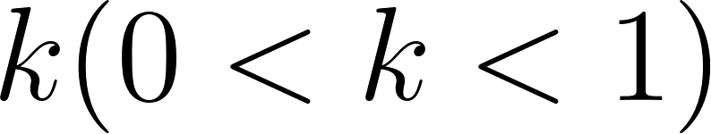](https://www.codecogs.com/eqnedit.php?latex=k%20(0%20%3C%20k%20%3C%201)#0). The function [](https://www.codecogs.com/eqnedit.php?latex=g(X)#0) can be defined as [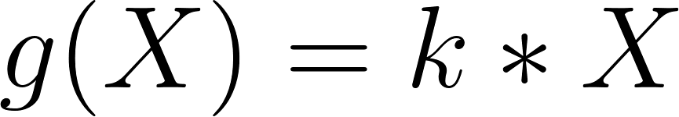](https://www.codecogs.com/eqnedit.php?latex=g(X)%20%3D%20k%20*%20X#0), representing the reduction in the number of infections due to the vaccine. Public health officials can use LOTUS to estimate the expected reduction in infections and use this information to optimize the vaccination campaign.

5. Environmental studies: Consider a factory that emits a certain amount of pollutants into a river, and let [](https://www.codecogs.com/eqnedit.php?latex=X#0) represent the pollutant concentration in the river, with a known probability density function [](https://www.codecogs.com/eqnedit.php?latex=f(x)#0). The survival rate of a specific fish species in the river is affected by the pollutant concentration. Researchers can define a function [](https://www.codecogs.com/eqnedit.php?latex=g(X)#0) that represents the survival rate of the fish as a function of pollutant concentration. Using LOTUS, the researchers can estimate the expected fish survival rate and use this information to assess the ecological impact of the pollution and recommend appropriate regulations.

**Not all statisticians agree with the name of this theorem.**

**In Casella, G., & Berger, R. L. (2002). Statistical inference. Belmont, CA: Duxbury on page 55, there is a mention of this. It says "Ross 1988 refers to this as the 'law of the unconscious statistician'. We do not find this amusing."**

## Uniform LOTUS Example

The probability density function for a uniform random variable with [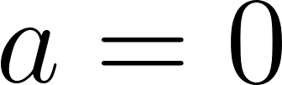](https://www.codecogs.com/eqnedit.php?latex=a%3D0#0) and [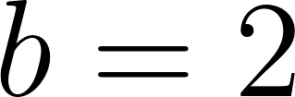](https://www.codecogs.com/eqnedit.php?latex=b%3D2#0) is [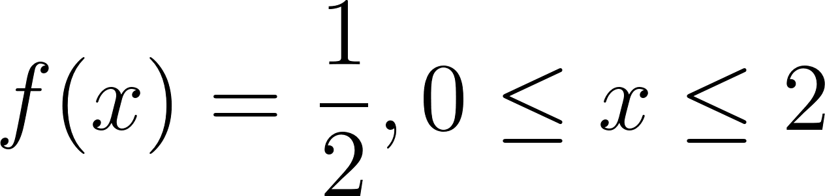](https://www.codecogs.com/eqnedit.php?latex=f(x)%3D%5Cdfrac%7B1%7D%7B2%7D%2C%200%20%5Cleq%20x%20%5Cleq%202#0).

[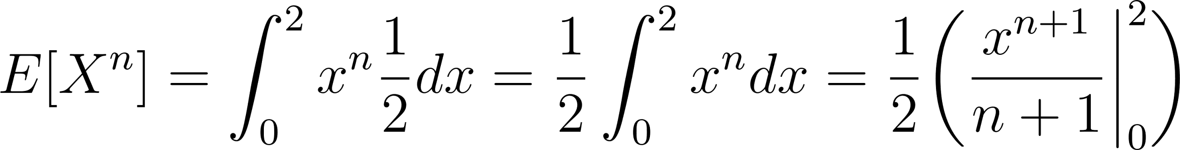](https://www.codecogs.com/eqnedit.php?latex=E%5BX%5En%5D%3D%5Cint_0%5E2%20x%5En%20%5Cdfrac%7B1%7D%7B2%7Ddx%3D%5Cdfrac%7B1%7D%7B2%7D%5Cint_0%5E2%20x%5En%20dx%3D%5Cdfrac%7B1%7D%7B2%7D%5Cbigg(%5Cdfrac%7Bx%5E%7Bn%2B1%7D%7D%7Bn%2B1%7D%20%20%5Cbigg%20%5Crvert_0%5E2%20%5Cbigg)#0)

[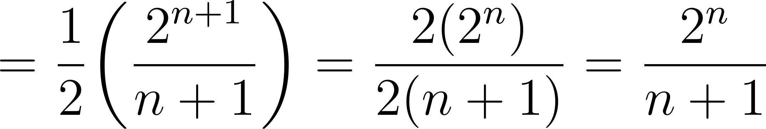](https://www.codecogs.com/eqnedit.php?latex=%3D%5Cdfrac%7B1%7D%7B2%7D%20%5Cbigg(%5Cdfrac%7B2%5E%7Bn%2B1%7D%7D%7Bn%2B1%7D%20%5Cbigg)%3D%5Cdfrac%7B2(2%5En)%7D%7B2(n%2B1)%7D%3D%5Cdfrac%7B2%5En%7D%7Bn%2B1%7D#0)

# Moments and Variance

Proof of [](https://www.codecogs.com/eqnedit.php?latex=%5Ctext%7BVar%7D(X)%3DE%5BX%5E2%5D-(E%5BX%5D)%5E2#0)

[](https://www.codecogs.com/eqnedit.php?latex=%5Ctext%7BVar%7D(X)%3DE%5B(X%20-%20E%5BX%5D)%5E2%5D%3DE%5BX%5E2%20-%202XE%5BX%5D%2B(E%5BX%5D)%5E2%5D#0)

[](https://www.codecogs.com/eqnedit.php?latex=%3DE%5BX%5E2%5D-2E%5BX%5DE%5BX%5D%2B(E%5BX%5D)%5E2%3DE%5BX%5E2%5D-2(E%5BX%5D)%5E2%2B(E%5BX%5D)%5E2#0)

[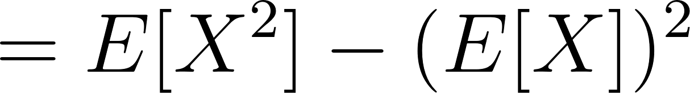](https://www.codecogs.com/eqnedit.php?latex=%3DE%5BX%5E2%5D-(E%5BX%5D)%5E2#0)

## Bernoulli Variance Example

[](https://www.codecogs.com/eqnedit.php?latex=E%5BX%5E2%5D%3D(1)%5E2(p)%2B(0)%5E2(1-p)%3Dp#0)

[](https://www.codecogs.com/eqnedit.php?latex=E%5BX%5E2%5D-(E%5BX%5D)%5E2%3Dp-p%5E2%3Dp(1-p)#0)

## Exponential Variance Example

The methods above in the Exponential Expected Value sections can be used to help calculate [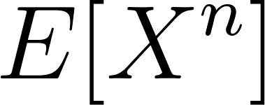](https://www.codecogs.com/eqnedit.php?latex=E%5BX%5En%5D#0).

### Transforming Using the Gamma Distribution

We can use parameters for the gamma distribution of [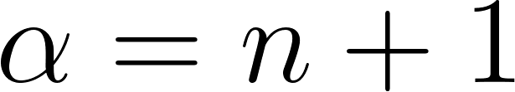](https://www.codecogs.com/eqnedit.php?latex=%5Calpha%3Dn%2B1#0) and [](https://www.codecogs.com/eqnedit.php?latex=%5Cbeta%3D%5Clambda#0) and rewrite the integral as:

[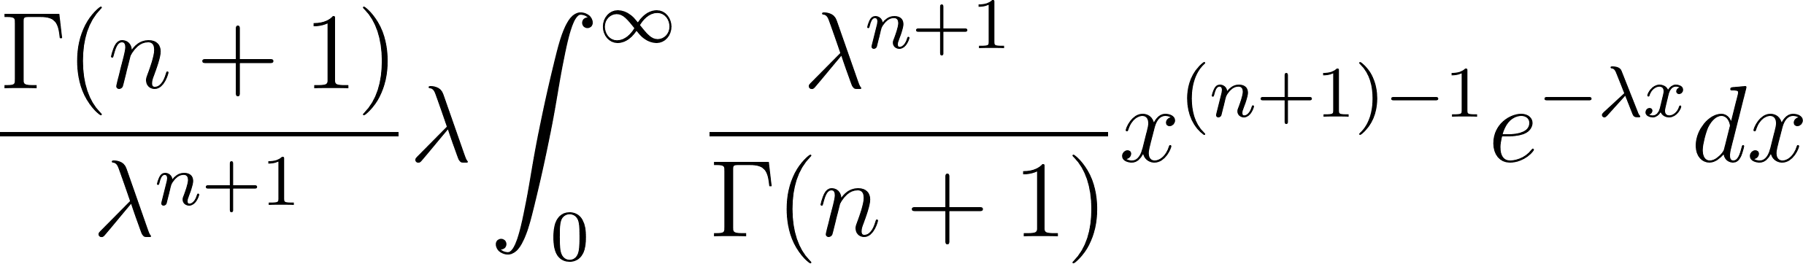](https://www.codecogs.com/eqnedit.php?latex=%5Cdfrac%7B%5CGamma(n%2B1)%7D%7B%5Clambda%5E%7Bn%2B1%7D%7D%5Clambda%20%5Cint_0%5E%7B%5Cinfty%7D%20%5Cdfrac%7B%5Clambda%5E%7Bn%2B1%7D%7D%7B%5CGamma(n%2B1)%7Dx%5E%7B(n%2B1)-1%7De%5E%7B-%5Clambda%20x%7Ddx#0)

The integral simplifies to 1 since that is the pdf of the gamma distribution with parameters defined above.

[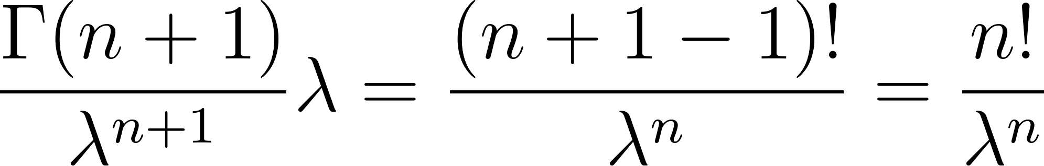](https://www.codecogs.com/eqnedit.php?latex=%5Cdfrac%7B%5CGamma(n%2B1)%7D%7B%5Clambda%5E%7Bn%2B1%7D%7D%5Clambda%3D%5Cdfrac%7B(n%2B1-1)!%7D%7B%5Clambda%5En%7D%3D%5Cdfrac%7Bn!%7D%7B%5Clambda%5En%7D#0)

### Transforming Using the Gamma Function

Rewrite the original integral as

[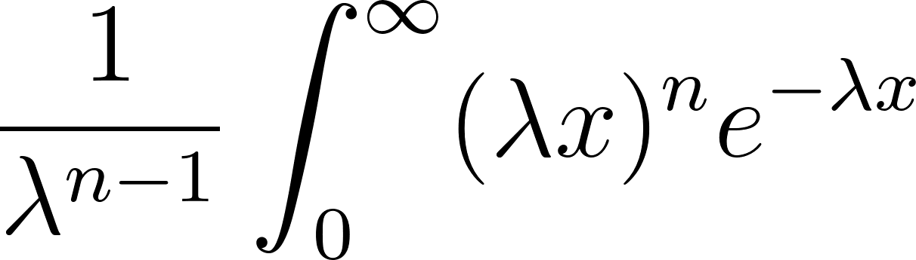](https://www.codecogs.com/eqnedit.php?latex=%5Cdfrac%7B1%7D%7B%5Clambda%5E%7Bn-1%7D%7D%20%5Cint_0%5E%7B%5Cinfty%7D%20(%5Clambda%20x)%5En%20e%5E%7B-%5Clambda%20x%7D#0)

Let [](https://www.codecogs.com/eqnedit.php?latex=t%3D%5Clambda%20x#0) and [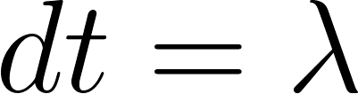](https://www.codecogs.com/eqnedit.php?latex=dt%20%3D%20%5Clambda#0) so that [](https://www.codecogs.com/eqnedit.php?latex=dx%20%3D%20%5Cdfrac%7Bdt%7D%7B%5Clambda%7D#0)

[](https://www.codecogs.com/eqnedit.php?latex=%5Cdfrac%7B1%7D%7B%5Clambda%5E%7Bn-1%7D%7D%20%5Cint_0%5E%7B%5Cinfty%7D%20t%5En%20e%5E%7B-t%7D%20%5Cdfrac%7Bdt%7D%7B%5Clambda%7D%3D%5Cdfrac%7B1%7D%7B%5Clambda%7D%5Cint_0%5E%7B%5Cinfty%7D%20t%5En%20e%5E%7B-t%7D%20dt%3D%5Cdfrac%7B1%7D%7B%5Clambda%5En%7D%5CGamma(n%2B1)%3D%5Cdfrac%7B(n%2B1-1)!%7D%7B%5Clambda%5En%7D%3D%5Cdfrac%7Bn!%7D%7B%5Clambda%5En%7D#0)

Note that if we let [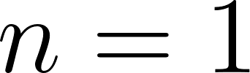](https://www.codecogs.com/eqnedit.php?latex=n%3D1#0) here we would be finding [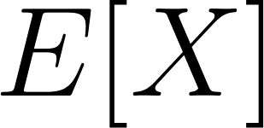](https://www.codecogs.com/eqnedit.php?latex=E%5BX%5D#0) and that would be [](https://www.codecogs.com/eqnedit.php?latex=%5Cdfrac%7B1%7D%7B%5Clambda%7D#0) which matches our answer above in the section Exponential Expect Value Example.

[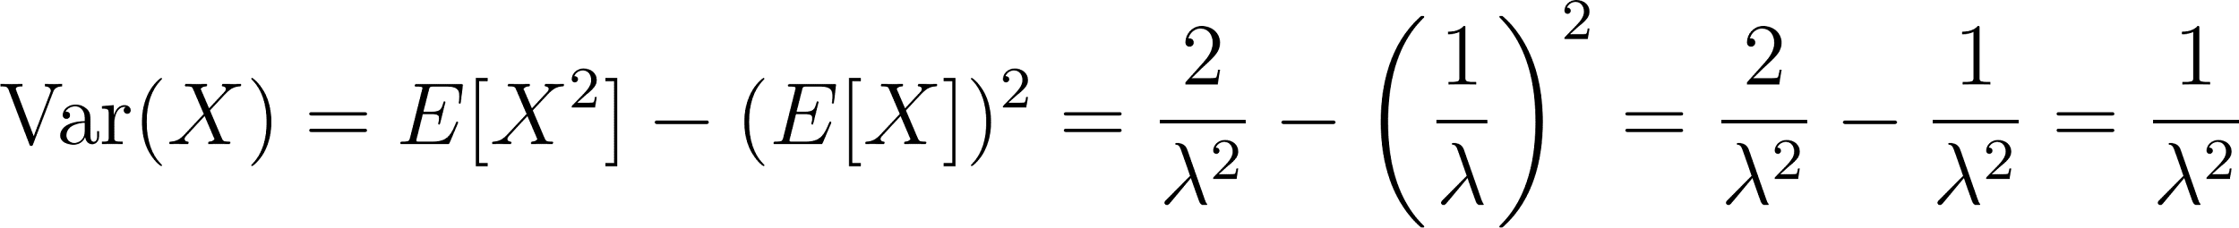](https://www.codecogs.com/eqnedit.php?latex=%5Ctext%7BVar%7D(X)%3DE%5BX%5E2%5D-(E%5BX%5D)%5E2%3D%5Cdfrac%7B2%7D%7B%5Clambda%5E2%7D-%5Cbigg(%5Cdfrac%7B1%7D%7B%5Clambda%7D%20%5Cbigg)%5E2%3D%5Cdfrac%7B2%7D%7B%5Clambda%5E2%7D-%5Cdfrac%7B1%7D%7B%5Clambda%5E2%7D%3D%5Cdfrac%7B1%7D%7B%5Clambda%5E2%7D#0)

# Expected Value and Variance Linear Combination Theorems

[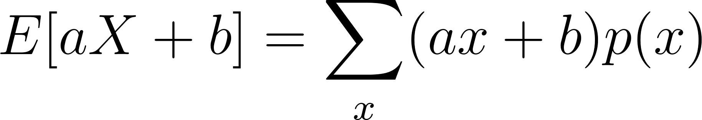](https://www.codecogs.com/eqnedit.php?latex=E%5BaX%2Bb%5D%3D%20%5Csum_%7Bx%7D(ax%2Bb)p(x)#0)

[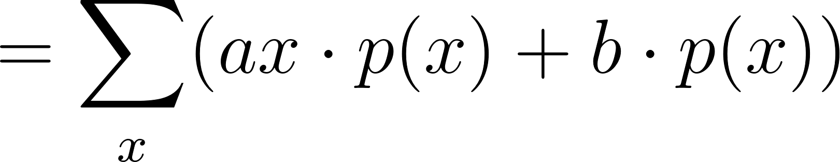](https://www.codecogs.com/eqnedit.php?latex=%3D%5Csum_%7Bx%7D(ax%5Ccdot%20p(x)%2Bb%5Ccdot%20p(x))#0)

[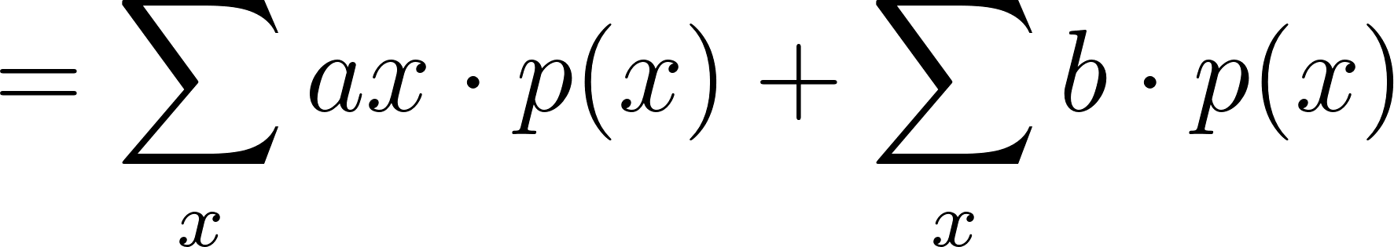](https://www.codecogs.com/eqnedit.php?latex=%3D%5Csum_%7Bx%7Dax%5Ccdot%20p(x)%20%2B%20%5Csum_%7Bx%7Db%5Ccdot%20p(x)#0)

[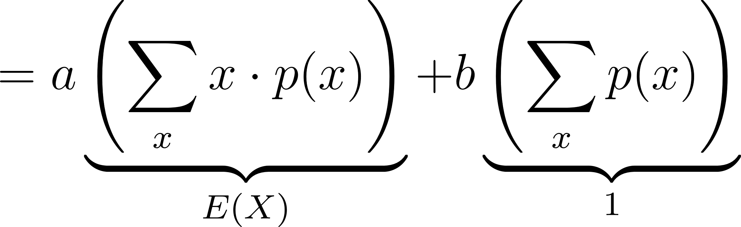](https://www.codecogs.com/eqnedit.php?latex=%3Da%5Cunderbrace%7B%5Cleft(%5Csum_%7Bx%7Dx%5Ccdot%20p(x)%5Cright)%7D_%7BE(X)%7D%20%2B%20b%5Cunderbrace%7B%5Cleft(%5Csum_%7Bx%7Dp(x)%5Cright)%7D_%7B1%7D#0)

[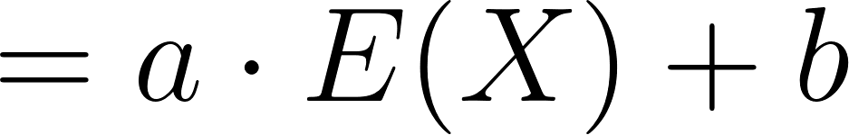](https://www.codecogs.com/eqnedit.php?latex=%3Da%5Ccdot%20E(X)%20%2B%20b%20%5C%5C#0)

[](https://www.codecogs.com/eqnedit.php?latex=%5Ctext%7BVar%7D(aX%2Bb)%3DE%5B(aX%2Bb)%5E2%5D-(E%5BaX%2Bb%5D)%5E2#0)

[](https://www.codecogs.com/eqnedit.php?latex=%3DE%5Ba%5E2X%5E2%2B2abX%2Bb%5E2%5D-(aE%5BX%5D%2Bb)%5E2#0)

[](https://www.codecogs.com/eqnedit.php?latex=%3Da%5E2E%5BX%5E2%5D%2B2abE%5BX%5D%2Bb%5E2-a%5E2(E%5BX%5D)%5E2-2abE%5BX%5D-b%5E2#0)

[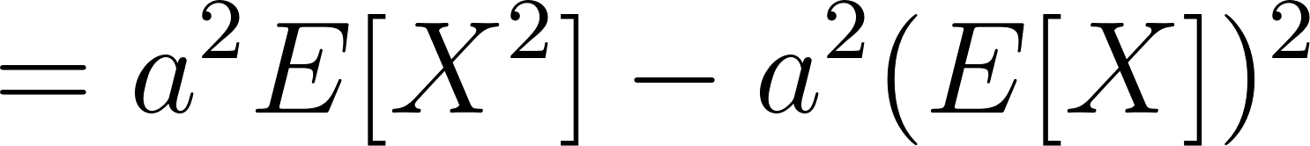](https://www.codecogs.com/eqnedit.php?latex=%3Da%5E2E%5BX%5E2%5D-a%5E2(E%5BX%5D)%5E2#0)

[](https://www.codecogs.com/eqnedit.php?latex=%3Da%5E2(E%5BX%5E2%5D-(E%5BX%5D)%5E2%3Da%5E2%5Ctext%7BVar%7D(X)#0)

# Just a Moment!

[Moment Generating Functions (MGFs)](https://en.wikipedia.org/wiki/Moment-generating_function) are mathematical tools used in probability theory and statistics to describe the probability distribution of a random variable. They provide an alternative representation of a probability distribution and are useful for deriving important properties and characteristics of the distribution, such as moments and [cumulants](https://en.wikipedia.org/wiki/Cumulant).

MGFs have several important properties:

* Linearity: If X and Y are independent random variables, the MGF of their sum is the product of their MGFs: [](https://www.codecogs.com/eqnedit.php?latex=M_%7B(X%2BY)%7D(t)%20%3D%20M_X(t)%20*%20M_Y(t)#0).
* Uniqueness: If two random variables have the same MGF, they have the same probability distribution.
* Transformations: If [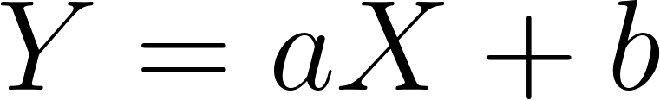](https://www.codecogs.com/eqnedit.php?latex=Y%20%3D%20aX%20%2B%20b#0), where [](https://www.codecogs.com/eqnedit.php?latex=a#0) and [](https://www.codecogs.com/eqnedit.php?latex=b#0) are constants, then [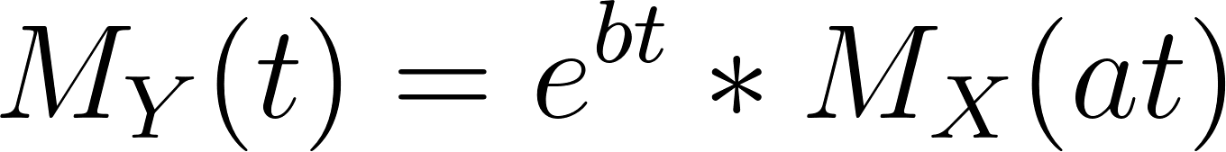](https://www.codecogs.com/eqnedit.php?latex=M_Y(t)%20%3D%20e%5E%7Bbt%7D%20*%20M_X(at)#0).

Specifically, moments help capture essential characteristics of a distribution, such as its [central tendency, dispersion, skewness, and kurtosis](https://en.wikipedia.org/wiki/Moment_(mathematics)#Notable_moments):

* [Central tendency](https://en.wikipedia.org/wiki/Mean) (1st moment): In finance, the first moment (the mean) of the return distribution of an asset (e.g., a stock) is used to estimate its expected return. Investors use this information to compare and select assets based on their potential to generate returns.
* [Dispersion](https://en.wikipedia.org/wiki/Variance) (2nd moment): The second moment, or the variance, measures the dispersion or spread of a distribution. In manufacturing, for instance, engineers monitor the variance in the dimensions of produced items to ensure that the manufacturing process is under control and that the items meet quality standards. A low variance implies consistent production, while a high variance might require adjustments to the process to reduce variability.
* [Skewness](https://en.wikipedia.org/wiki/Skewness) (3rd moment): The third moment, or skewness, measures the asymmetry of a distribution. In finance, skewness can provide insights into potential investment risks. A positively skewed return distribution implies that there are more chances of extreme positive returns, while a negatively skewed distribution indicates a higher likelihood of extreme negative returns. This information can help investors select assets according to their risk tolerance and preferences.
* [Kurtosis](https://en.wikipedia.org/wiki/Kurtosis) (4th moment): The fourth moment, or kurtosis, measures the "tailedness" of a distribution. In hydrology, kurtosis can be used to study the distribution of extreme rainfall events. A high kurtosis value indicates that extreme events are more frequent than in a normal distribution, which can be crucial for flood risk assessment, infrastructure design, and water resource management.

The MGF works because it combines the useful properties of the [exponential function](https://en.wikipedia.org/wiki/Exponential_function) and the [Taylor series expansion](https://en.wikipedia.org/wiki/Taylor_series) to represent moments in a compact and convenient way. This representation enables the extraction of moments through derivatives, and it simplifies calculations involving sums or linear combinations of independent random variables.

The Taylor series expansion of [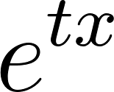](https://www.codecogs.com/eqnedit.php?latex=e%5E%7Btx%7D#0) is as follows:

[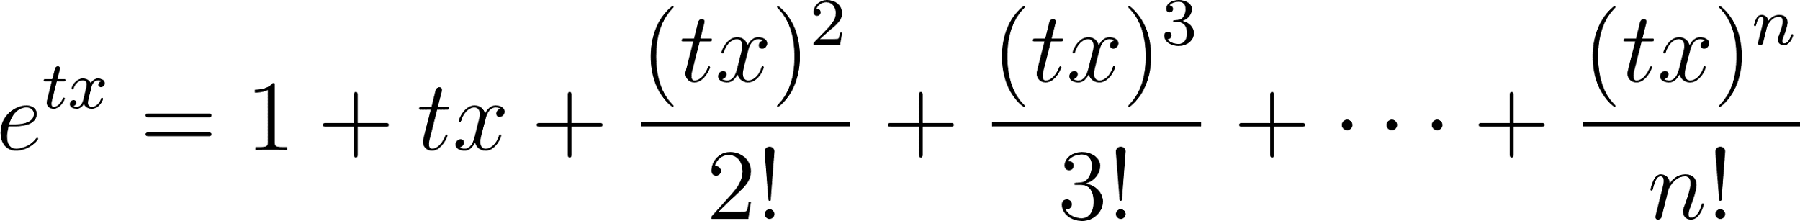](https://www.codecogs.com/eqnedit.php?latex=e%5E%7Btx%7D%3D1%2B%20tx%2B%20%5Cdfrac%7B(tx)%5E2%7D%7B2!%7D%2B%5Cdfrac%7B(tx)%5E3%7D%7B3!%7D%2B%20%5Cdots%20%2B%20%5Cdfrac%7B(tx)%5En%7D%7Bn!%7D#0)

When we take the expected value of [](https://www.codecogs.com/eqnedit.php?latex=e%5E%7Btx%7D#0), the expectation operates term by term on the Taylor series expansion:

[](https://www.codecogs.com/eqnedit.php?latex=E%5Be%5E%7Btx%7D%5D%3DE%5B1%5D%2B%20E%5Btx%5D%2B%20E%5Cbigg%5B%5Cdfrac%7B(tx)%5E2%7D%7B2!%7D%5Cbigg%5D%2BE%5Cbigg%5B%5Cdfrac%7B(tx)%5E3%7D%7B3!%7D%5Cbigg%5D%2B%20%5Cdots%20%2B%20E%5Cbigg%5B%5Cdfrac%7B(tx)%5En%7D%7Bn!%7D%5Cbigg%5D#0)

[](https://www.codecogs.com/eqnedit.php?latex=E%5Be%5E%7Btx%7D%5D%3DE%5B1%5D%2BtE%5Bx%5D%2Bt%5E2%20%5Cdfrac%7BE%5Bx%5E2%5D%7D%7B2!%7D%2Bt%5E3%20%5Cdfrac%7BE%5Bx%5E3%5D%7D%7B3!%7D%2B%20%5Cdots%20%2Bt%5En%20%5Cdfrac%7BE%5Bx%5En%5D%7D%7Bn!%7D#0)

The MGF becomes a power series in [](https://www.codecogs.com/eqnedit.php?latex=t#0) with the coefficients being the moments of the distribution.

Taking derivatives with respect to [](https://www.codecogs.com/eqnedit.php?latex=t#0) and evaluating at [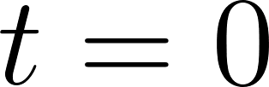](https://www.codecogs.com/eqnedit.php?latex=t%3D0#0) will result in the moments of the distribution.

The first derivative results in [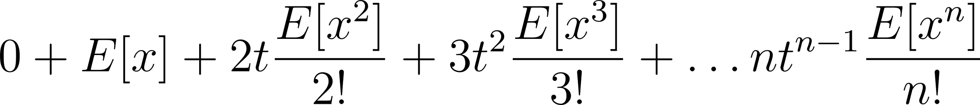](https://www.codecogs.com/eqnedit.php?latex=0%2BE%5Bx%5D%2B2t%20%5Cdfrac%7BE%5Bx%5E2%5D%7D%7B2!%7D%2B3t%5E2%20%5Cdfrac%7BE%5Bx%5E3%5D%7D%7B3!%7D%2B%5Cdots%20nt%5E%7Bn-1%7D%5Cdfrac%7BE%5Bx%5En%5D%7D%7Bn!%7D#0) evaluated at [](https://www.codecogs.com/eqnedit.php?latex=t%3D0#0) results in [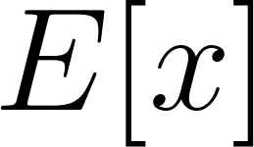](https://www.codecogs.com/eqnedit.php?latex=E%5Bx%5D#0) which is the first moment.

The second derivative results in [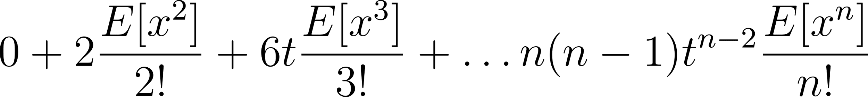](https://www.codecogs.com/eqnedit.php?latex=0%2B2%20%5Cdfrac%7BE%5Bx%5E2%5D%7D%7B2!%7D%2B%206t%20%5Cdfrac%7BE%5Bx%5E3%5D%7D%7B3!%7D%2B%5Cdots%20n(n-1)t%5E%7Bn-2%7D%5Cdfrac%7BE%5Bx%5En%5D%7D%7Bn!%7D#0) evaluated at [](https://www.codecogs.com/eqnedit.php?latex=t%3D0#0) results in [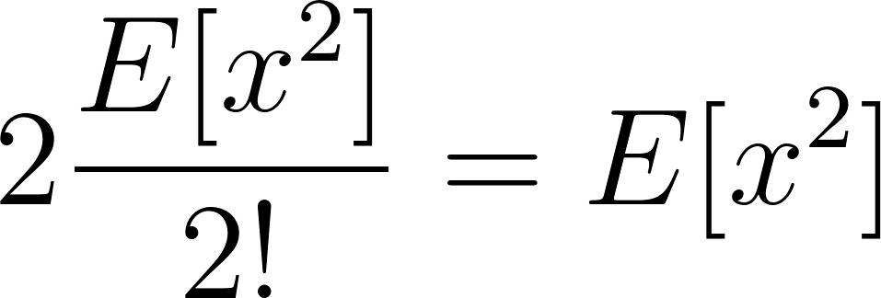](https://www.codecogs.com/eqnedit.php?latex=2%5Cdfrac%7BE%5Bx%5E2%5D%7D%7B2!%7D%3DE%5Bx%5E2%5D#0) which is the second moment.

The pattern continues on and each successive derivative evaluated at [](https://www.codecogs.com/eqnedit.php?latex=t%3D0#0) will be the corresponding moment of the distribution.

## Exponential Moment Example

[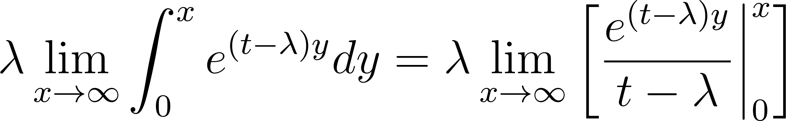](https://www.codecogs.com/eqnedit.php?latex=%5Clambda%20%5Clim_%7Bx%20%5Cto%20%5Cinfty%7D%20%5Cint_0%5Ex%20e%5E%7B(t-%5Clambda)y%7Ddy%3D%5Clambda%20%5Clim_%7Bx%20%5Cto%20%5Cinfty%7D%20%5Cbigg%5B%5Cdfrac%7Be%5E%7B(t-%5Clambda)y%7D%7D%7Bt-%5Clambda%7D%20%20%5Cbigg%20%5Crvert_0%5Ex%20%5Cbigg%5D#0)

This expression is only finite if [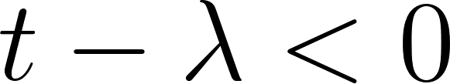](https://www.codecogs.com/eqnedit.php?latex=t-%5Clambda%20%3C%200#0) which is the same as [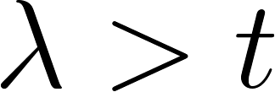](https://www.codecogs.com/eqnedit.php?latex=%5Clambda%20%3E%20t#0)

[](https://www.codecogs.com/eqnedit.php?latex=%5Clambda%20%5Clim_%7Bx%20%5Cto%20%5Cinfty%7D%20%5Cbigg%5B%5Cdfrac%7Be%5E%7B(t-%5Clambda)x%7D%7D%7Bt-%5Clambda%7D%20-%5Cdfrac%7Be%5E%7B(t-%5Clambda)(0)%7D%7D%7Bt-%5Clambda%7D%20%5Cbigg%5D%3D%5Clambda%20%5Cbigg%5B0-%5Cdfrac%7B1%7D%7Bt-%5Clambda%7D%20%5Cbigg%5D%3D%5Cdfrac%7B-%5Clambda%7D%7Bt-%5Clambda%7D%3D%5Cdfrac%7B%5Clambda%7D%7B%5Clambda%20-%20t%7D#0)

## Exponential MGF Example

The first derivative of [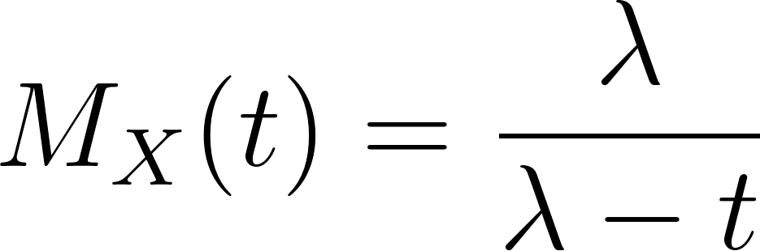](https://www.codecogs.com/eqnedit.php?latex=M_X(t)%3D%5Cdfrac%7B%5Clambda%7D%7B%5Clambda%20-t%7D#0) is [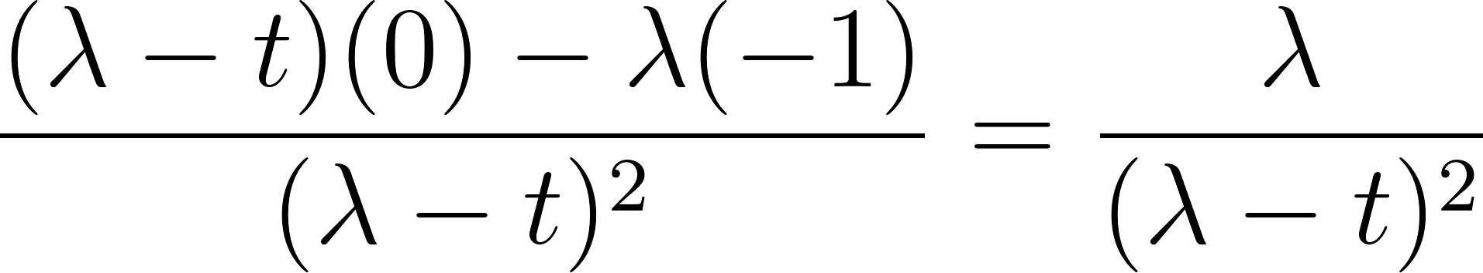](https://www.codecogs.com/eqnedit.php?latex=%5Cdfrac%7B(%5Clambda%20-%20t)(0)-%5Clambda(-1)%7D%7B(%5Clambda%20-%20t)%5E2%7D%3D%5Cdfrac%7B%5Clambda%7D%7B(%5Clambda%20-%20t)%5E2%7D#0) using the quotient rule.

Evaluated at [](https://www.codecogs.com/eqnedit.php?latex=t%3D0#0), [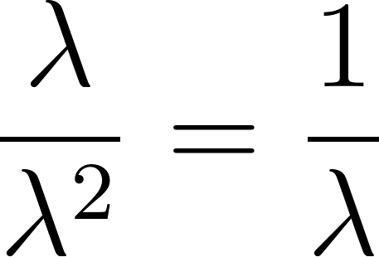](https://www.codecogs.com/eqnedit.php?latex=%5Cdfrac%7B%5Clambda%7D%7B%5Clambda%5E2%7D%3D%5Cdfrac%7B1%7D%7B%5Clambda%7D#0)

The second derivative is [](https://www.codecogs.com/eqnedit.php?latex=%5Cdfrac%7B(%5Clambda%20-t)%5E2(0)-%5Clambda(2(%5Clambda-t)(-1)%7D%7B(%5Clambda%20-t)%5E4%7D%3D%5Cdfrac%7B-%5Clambda(-2%5Clambda%2B2t)%7D%7B(%5Clambda-t)%5E4%7D%3D%5Cdfrac%7B2%5Clambda%5E2-2%5Clambda%20t%7D%7B(%5Clambda%20-%20t)%5E4%7D%3D%5Cdfrac%7B2%5Clambda(%5Clambda%20-t%20)%7D%7B(%5Clambda%20-%20t)%5E4%7D#0)

[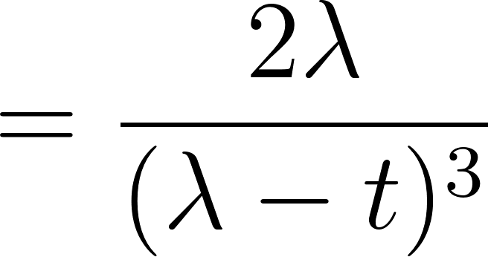](https://www.codecogs.com/eqnedit.php?latex=%3D%5Cdfrac%7B2%5Clambda%7D%7B(%5Clambda%20-%20t)%5E3%7D#0)

Evaluated at [](https://www.codecogs.com/eqnedit.php?latex=t%3D0#0), [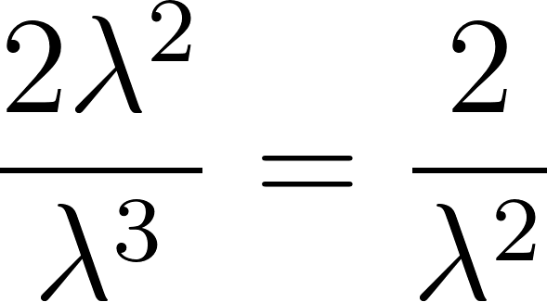](https://www.codecogs.com/eqnedit.php?latex=%5Cdfrac%7B2%5Clambda%5E2%7D%7B%5Clambda%5E3%7D%3D%5Cdfrac%7B2%7D%7B%5Clambda%5E2%7D#0)